Android Maps

Introduction

In this Application, we create an Android Maps application in which we can view the location of various places and store the history for future purposes.

Project Description

The Android Maps are created as an Android App, it is developed using Kotlin as a final project for the Android Development using Kotlin internship.

HomeScreen

It has a basic HomeScreen with a button widget to search for locations, the location can be any item that can be searched using Google Maps When the search button has been pressed the query from the search bar appears on Google Maps. Now Google Maps take this query, applies this to its application, and fetches back the results. When this is done the search in the search bar is taken into the History of the application, now whenever the same item needs to be searched, it just needs to be clicked on and the query will be passed. Thus negating the need to type queries, again and again.

Technologies-Used

### 1. MVVM (Model View ViewModel)

MVVM architecture in android is used to structure the project’s code and understand code easily. MVVM is an architectural design pattern in android. MVVM treats Activity classes and XML files as View. This design pattern separates UI from its logic. Here is an image to quickly understand MVVM.

### 2) ROOM Database

Room persistence library is a database management library and it is used to store the data of apps like grocery item name, grocery item quantity, and grocery item price. Room is a cover layer on SQLite which helps to perform the operation on the database easily.

### 3) RecycleView

RecyclerView is a container and it is used to display the collection of data in a large amount of data set that can be scrolled very effectively by maintaining a limited number of views.

### 4) Coroutines

Coroutines are lightweight threads, we use a coroutine to perform an operation on other threads, by this our main thread doesn’t block and our app doesn’t crash.

### 5) Google Maps API

We use the Google Maps API to get information regarding the location of various places posted in the query.

**NearBy Bussiness Search** - A mobile app is built where the user can search for his nearby locations based on his requirement. Whenever the user gives input of business type like a hotel, petrol pumps, hospitals, etc. using Place API and as a response we obtain the co-ordinates that are marked on the Google map.

This app uses Google maps to show up the results for which the user search for in this application. This helps the users to get to know the location of their required business place by just making a one time search. This appilcation makes ease of searching various types of business sectors to reduce complexity especially for job seekers.

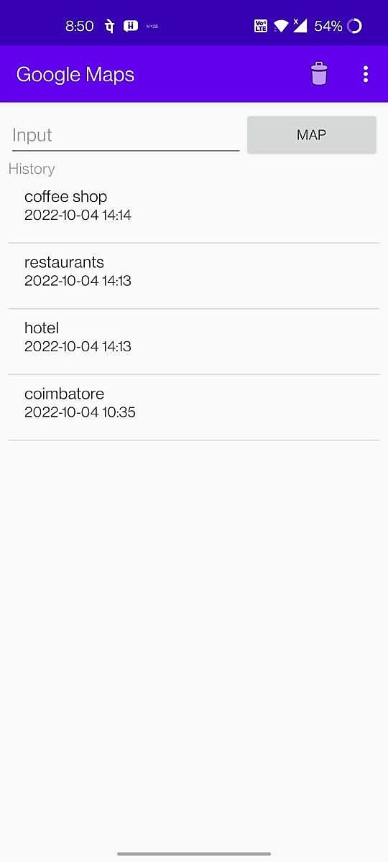

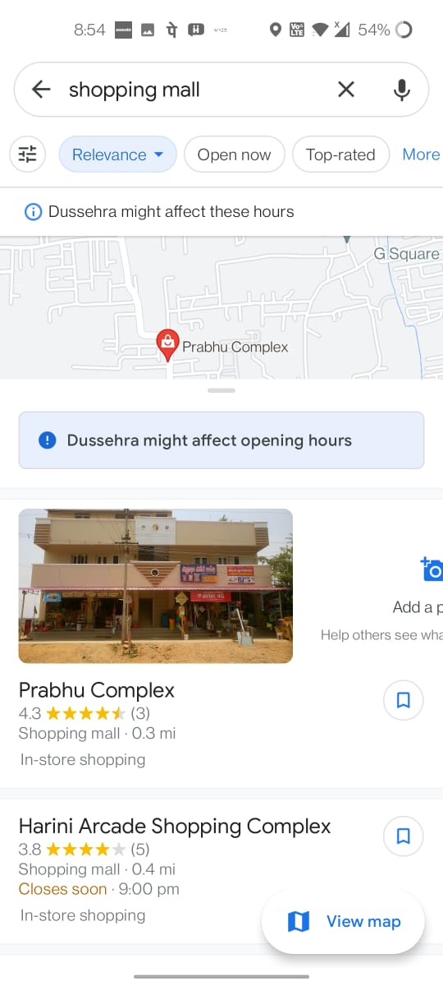

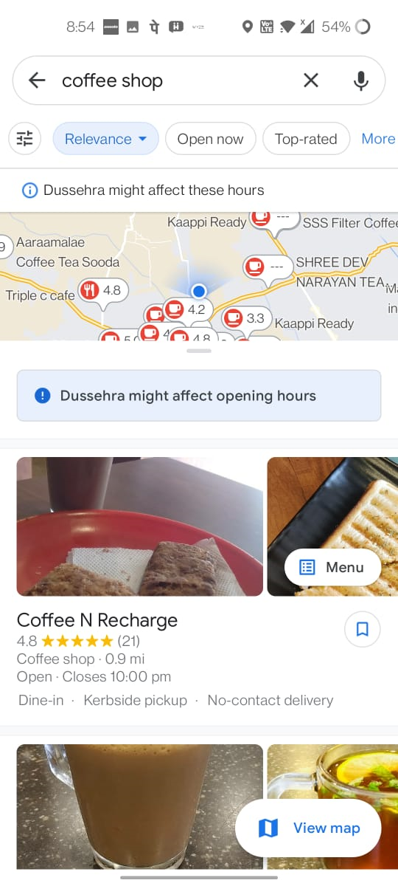

**Grocery List Applicaion**

Introduction

In this Application, we create an grocery list application in which we can view the list of grocery items with its Quantity and price estimation and store the history for future purposes.

Project Description

The grocery listing work can be done by using an Android App, it is developed using Kotlin as a final project for the Android Development using Kotlin internship.

HomeScreen

It has a basic HomeScreen with a button widget to add the grocery items, the items can be any of raw food item and cooking products that can be added using this application. When the add button has been pressed the query from the add button appears on UI . Now user would be asked with item name, item quantity and its price to be entered to this application, and fetches back the results. When this is done the item gets added to the list and next item gets added by the user using add button in a consecutive manner. Once everything gets added to the list the user can download it and it gets saved to the history for future use.so, next time the user would make changes to the existing list. This application also enables user to mark the items once it gets added to grocery basket to avoid chaos while shopping their groceries.

**Digital Grocery List** - As we can't remember everything, users frequently go to store & forget to buy the things they want to buy. However, with the assistance of this app, you can make a list of the groceries you intend to buy so that you don't forget anything.

This also enables user to get an estimation of their grocery list quickly and easily. This helps users to avoid missing of products while shopping grocery and reduce the complexity of homemakers and grocery products suppliers.

